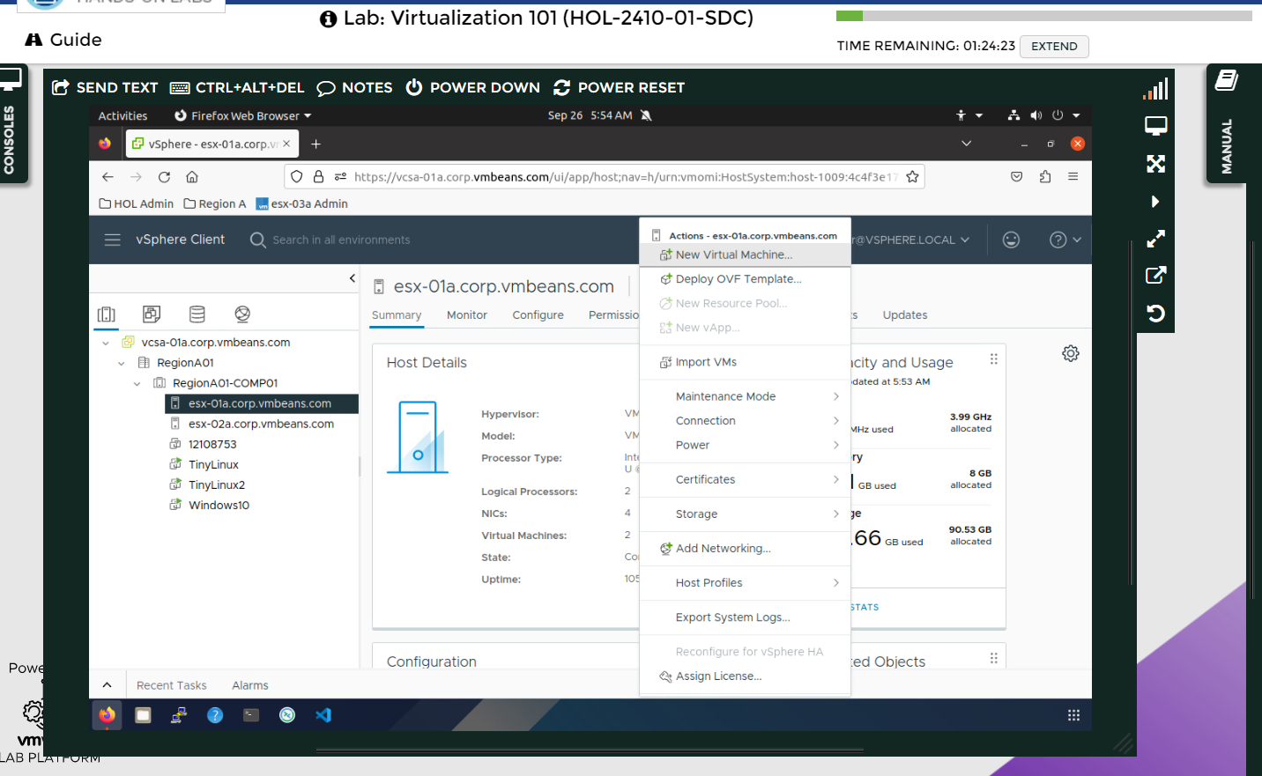
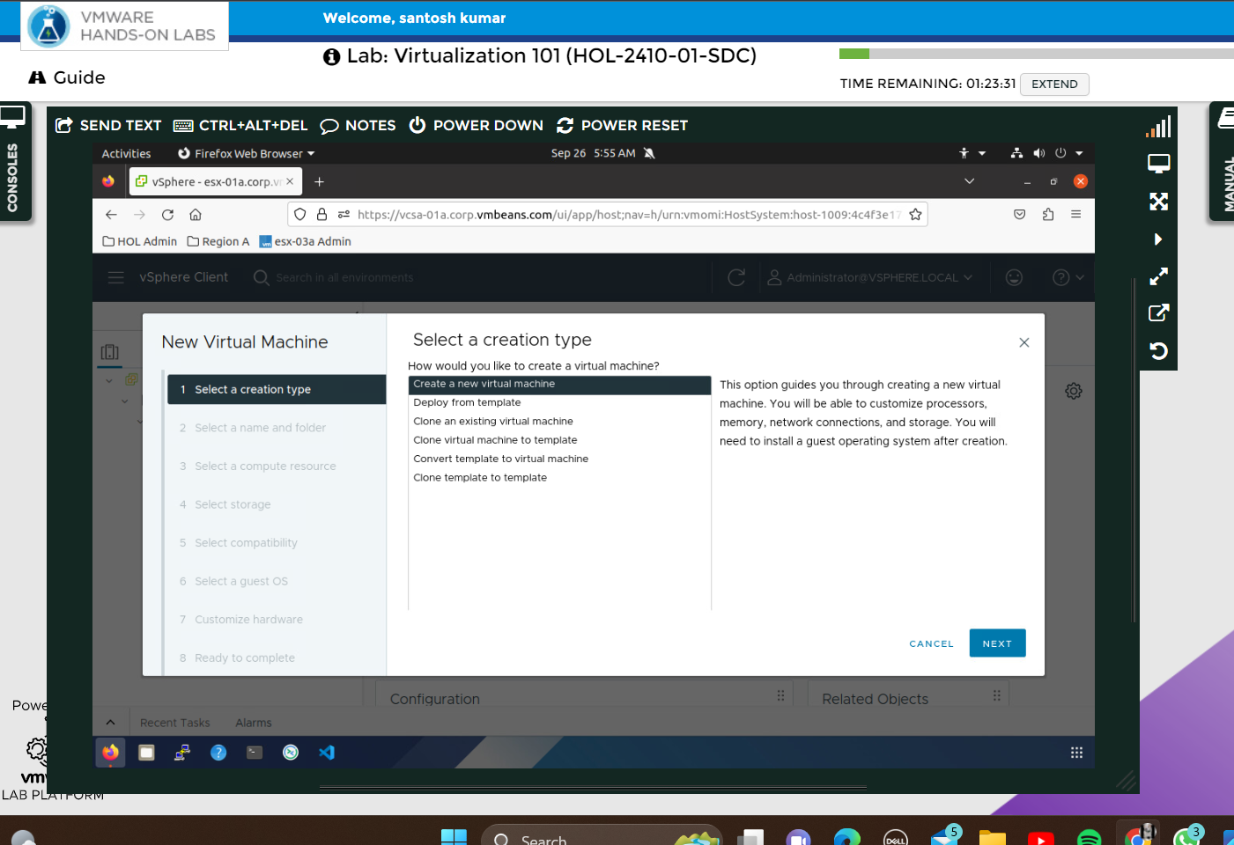
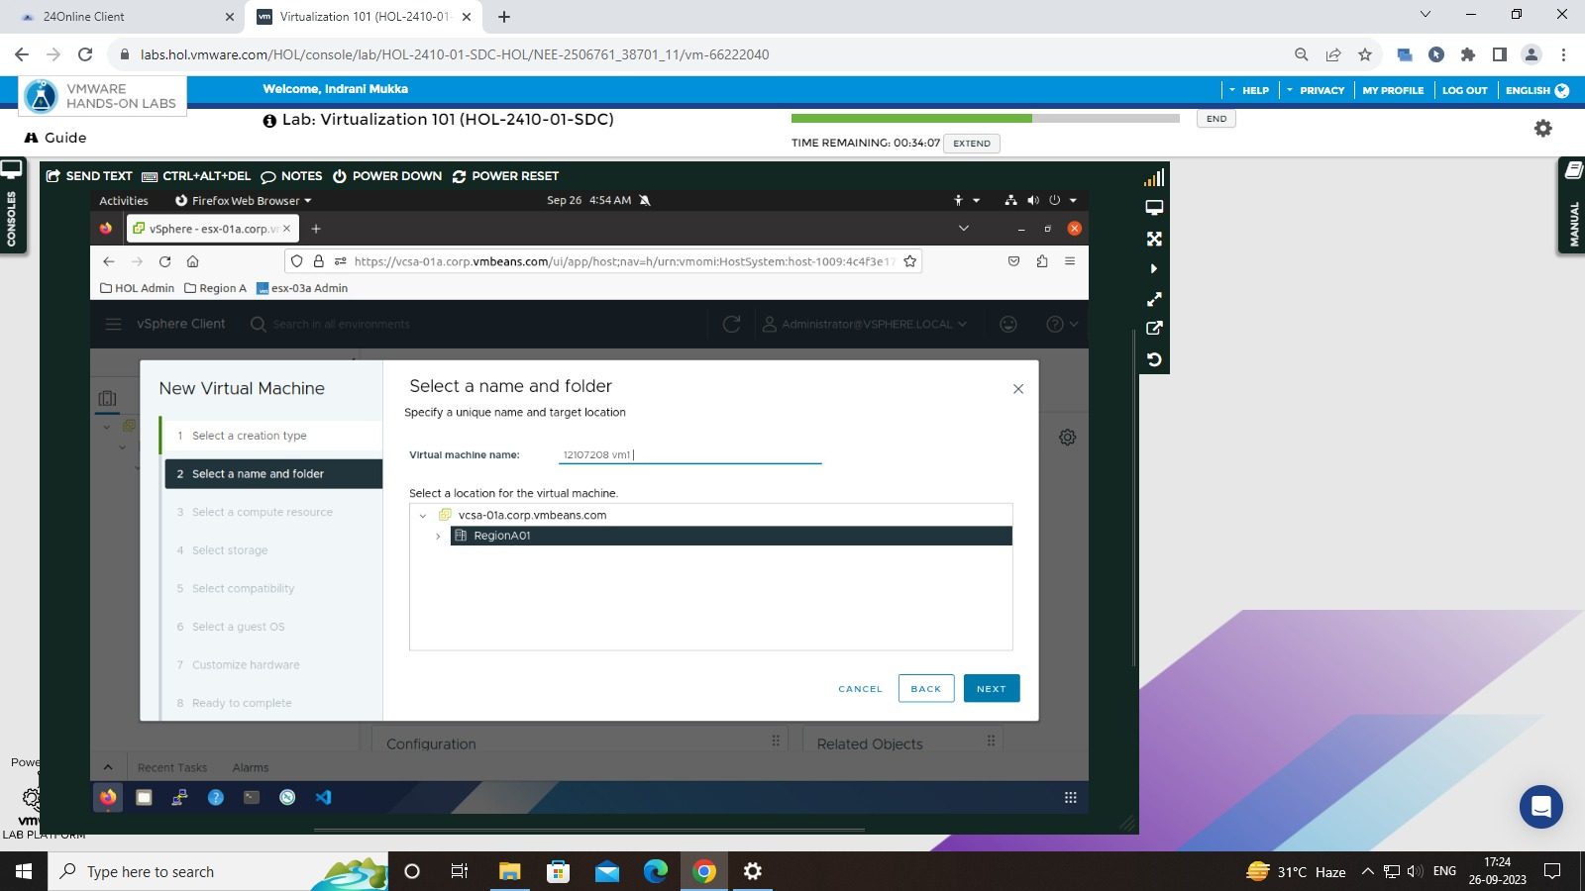
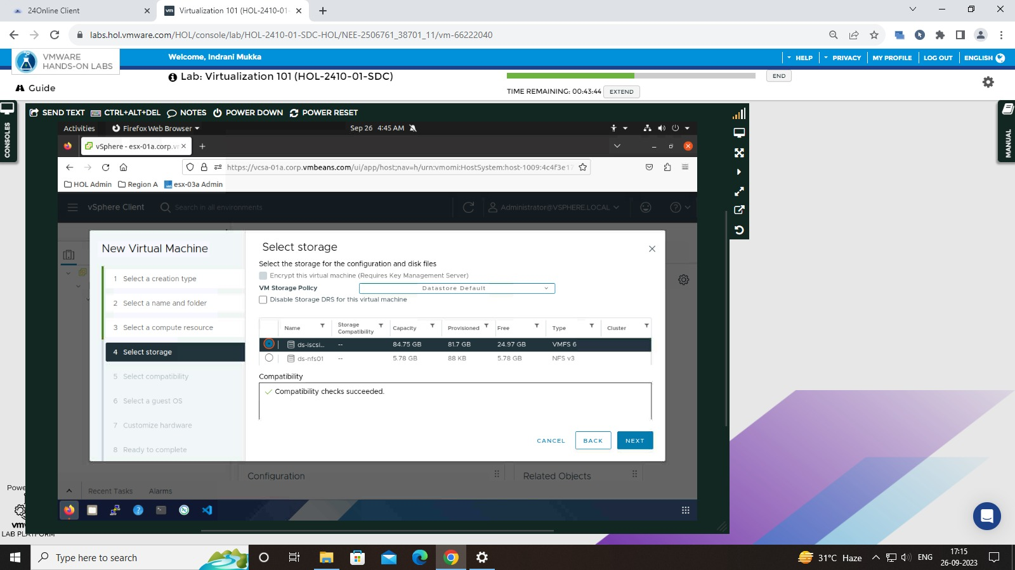
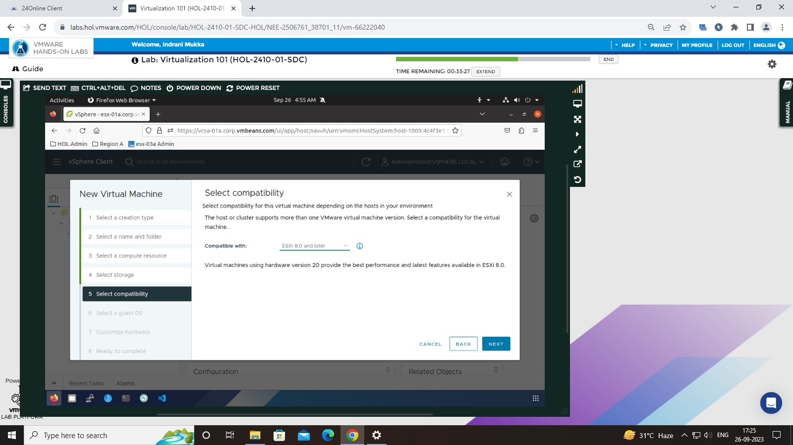
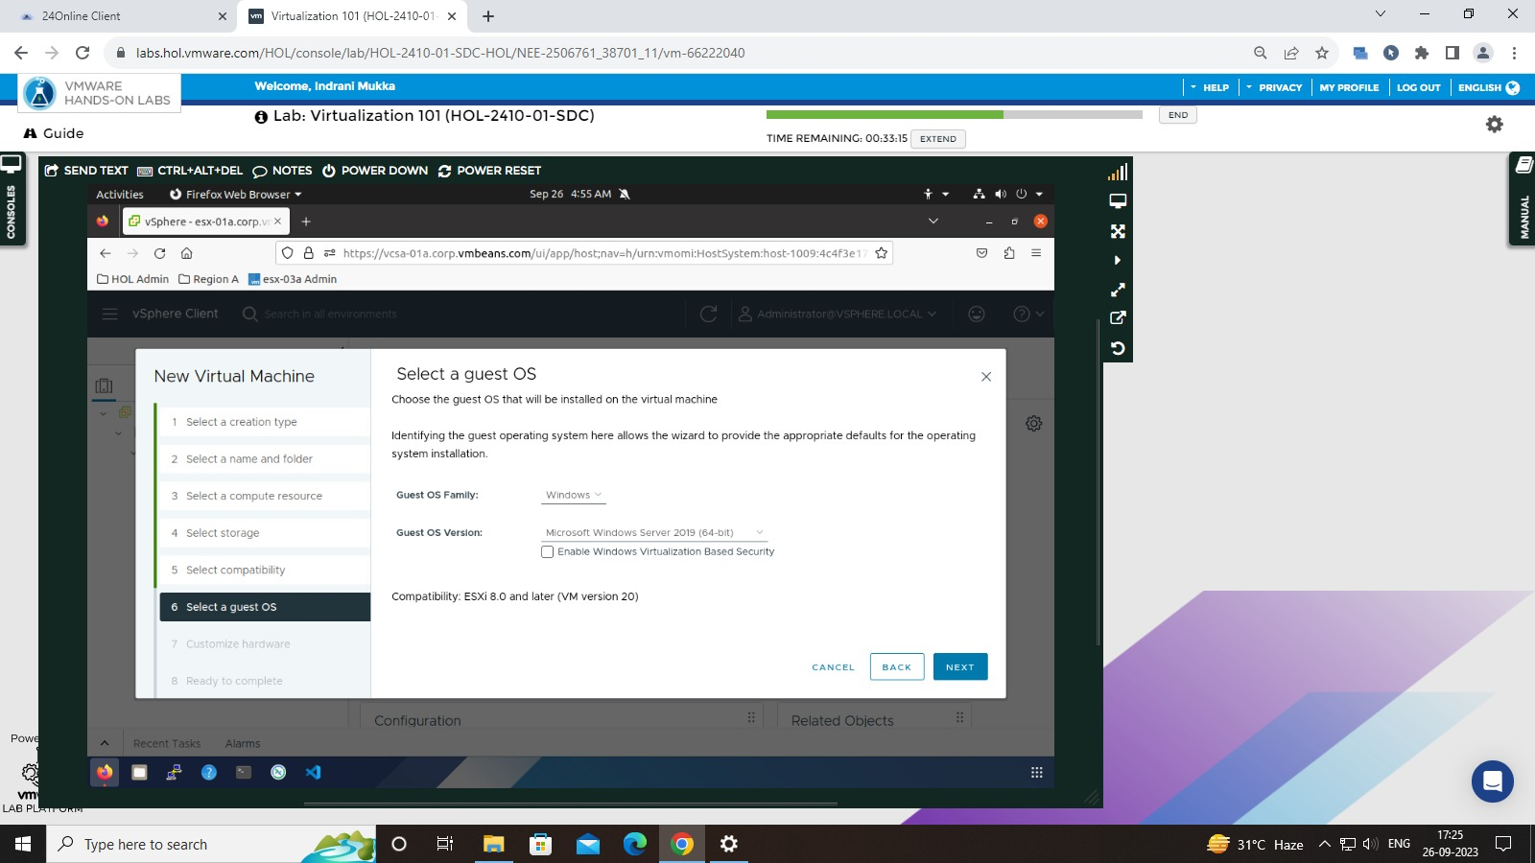
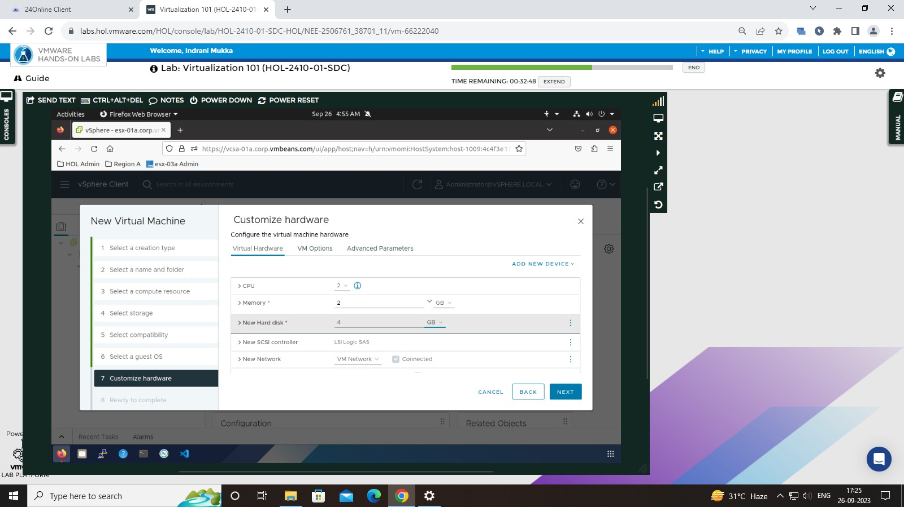
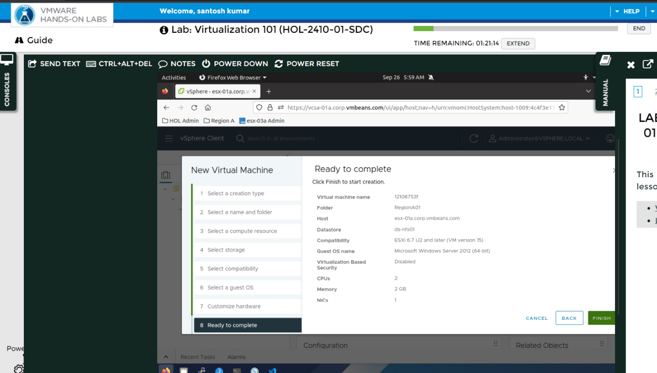
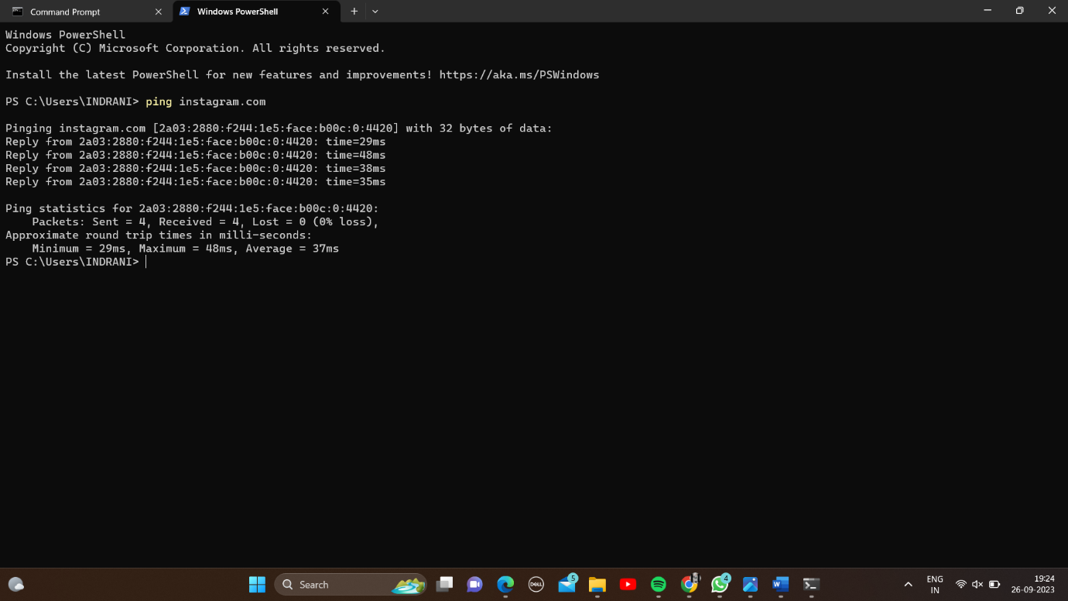
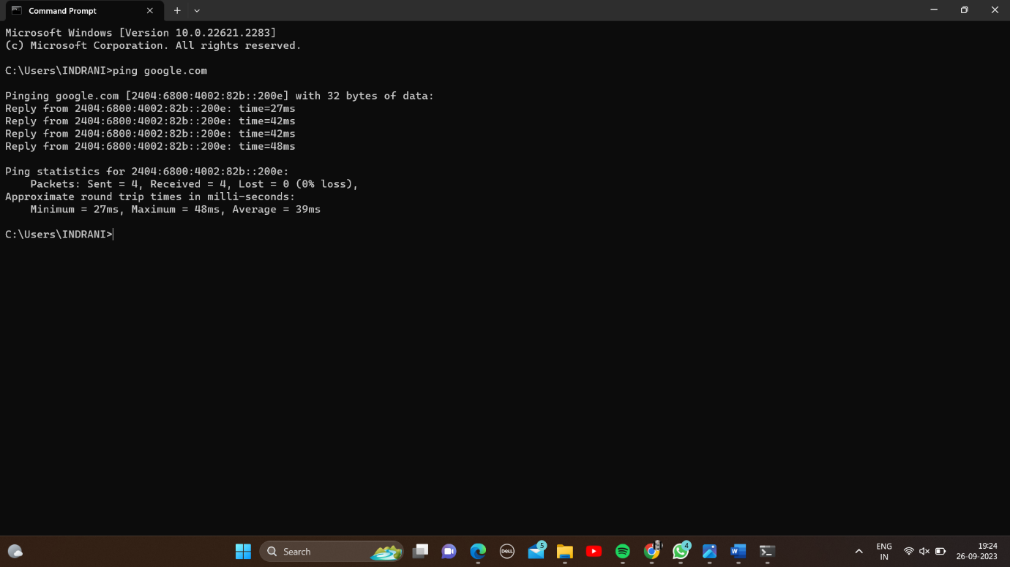
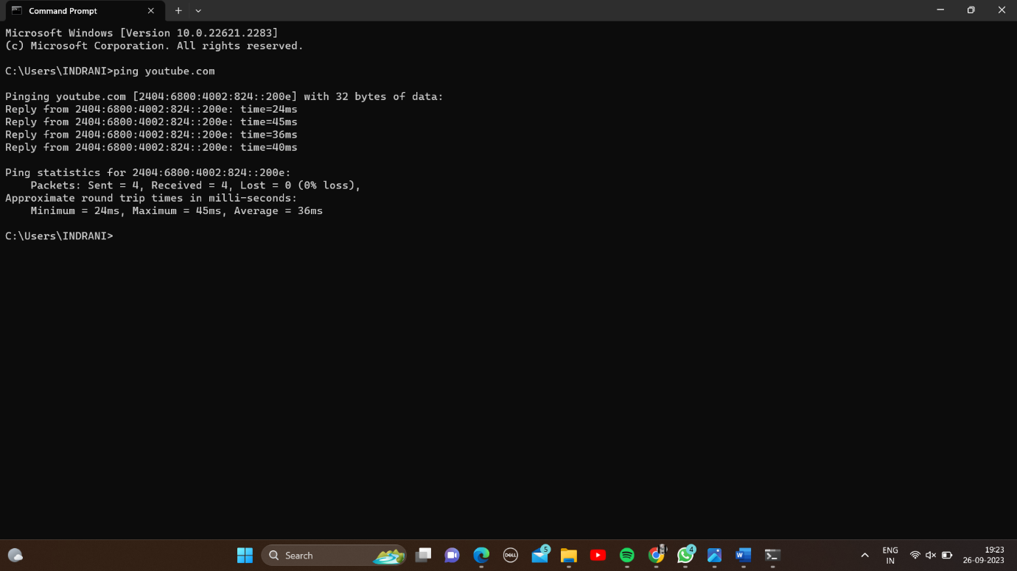
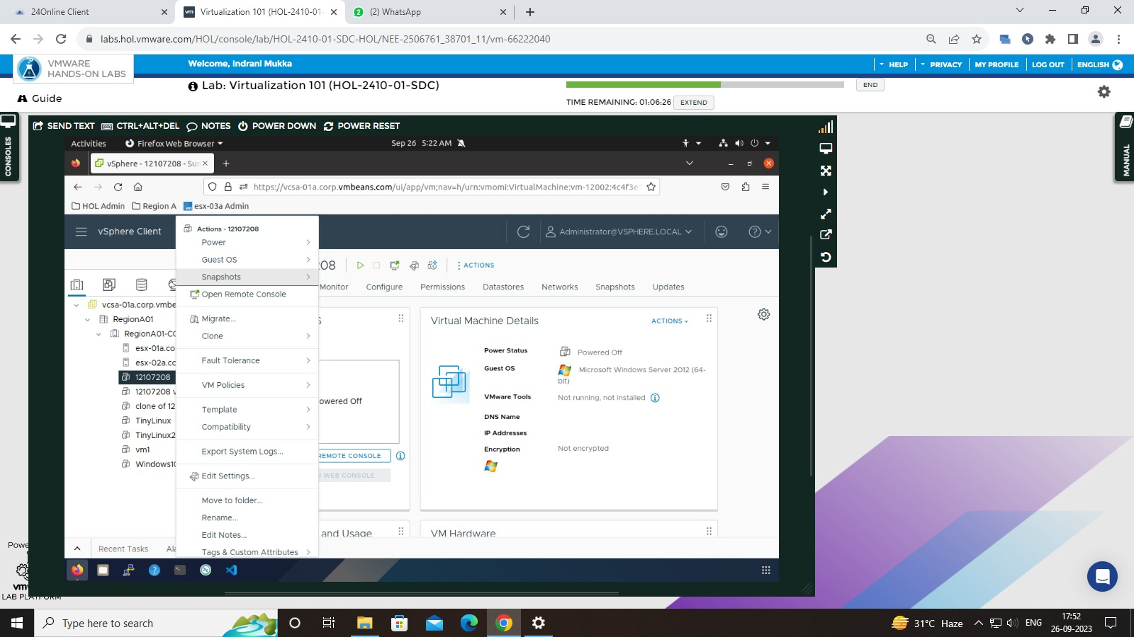
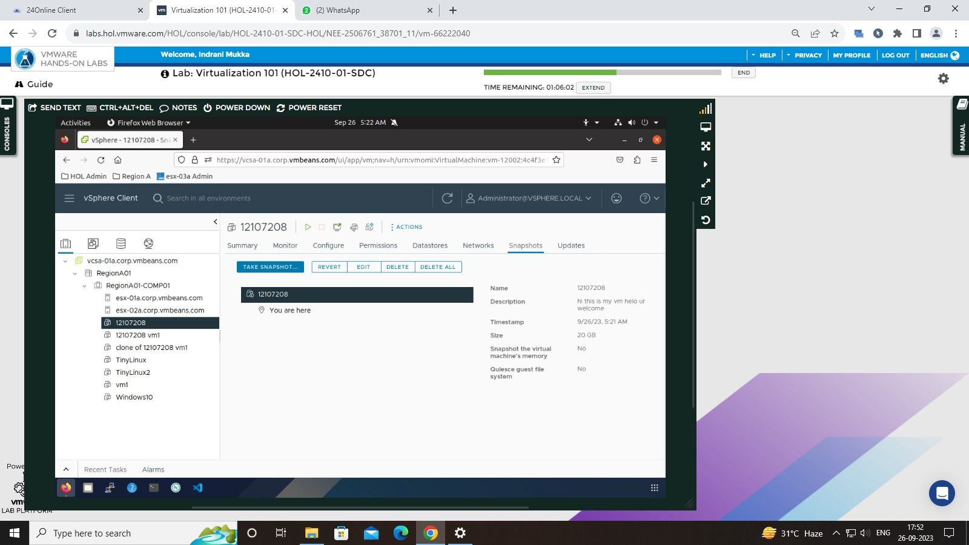
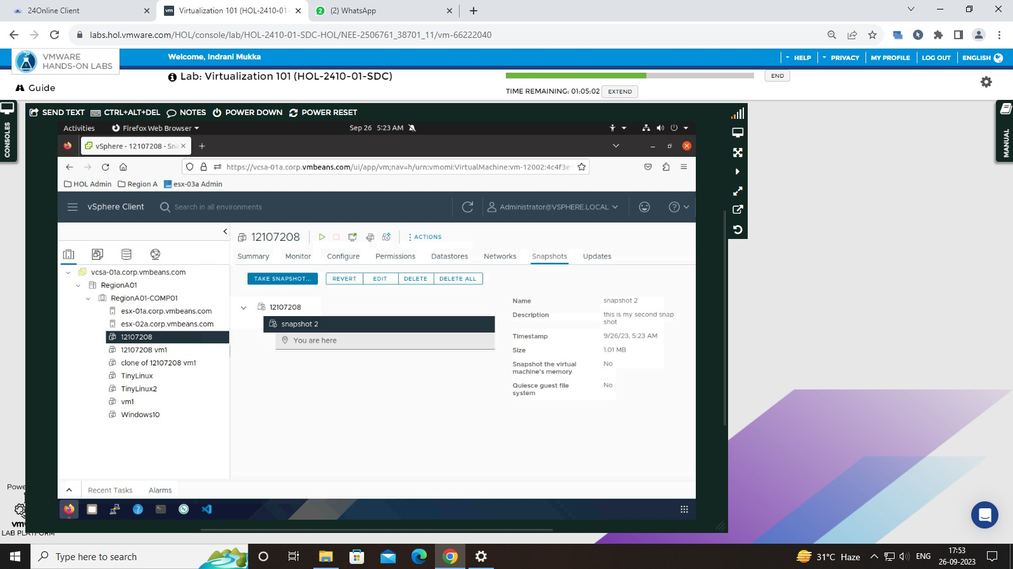
CA2
VIRTUALIZATION & CLOUD COMPUTING LABORATORY
Name: ARIJIT KUNDU
Reg No: 12106556
Roll No: RK21FMA06

Question1:
Creating Virtual Machine In HOL:
Step1:- Open the virtual machine and go on the action option
Step2:- Select a new virtual machine and click on it

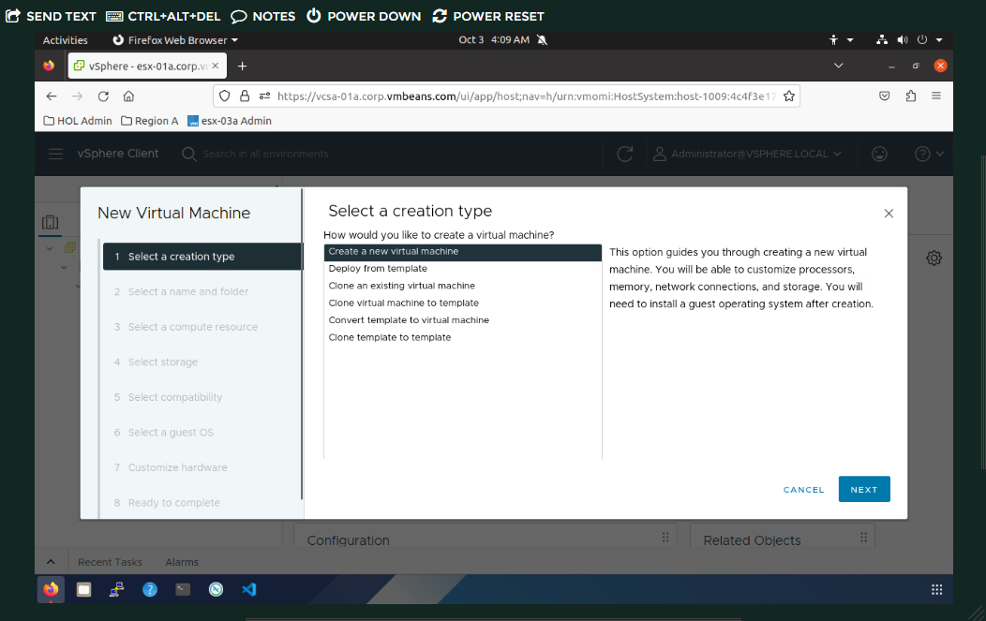
Step3:- Select a name and folder
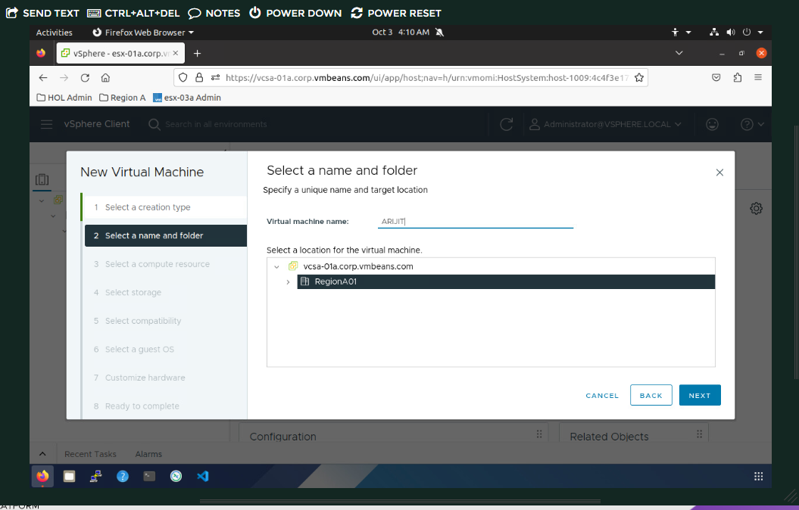

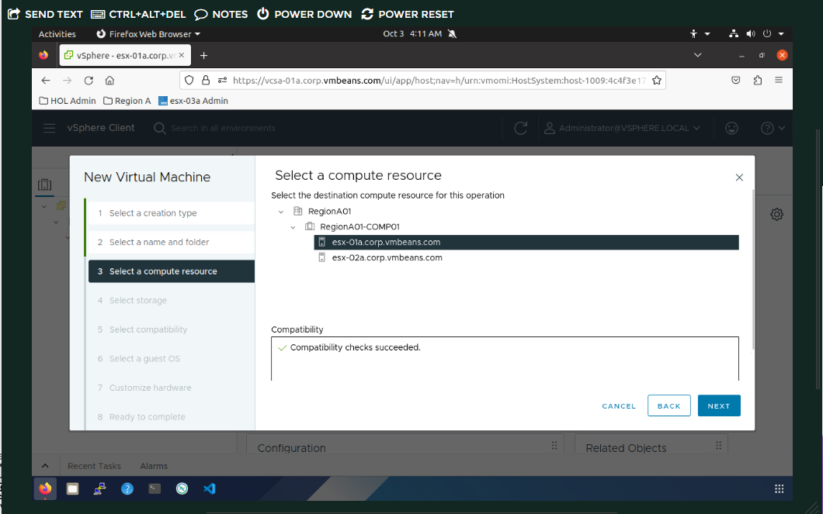
STEP 4: SELECT COMPUTER RESOURCES
Step5:- Select compatibility go on the window option and choose Linux

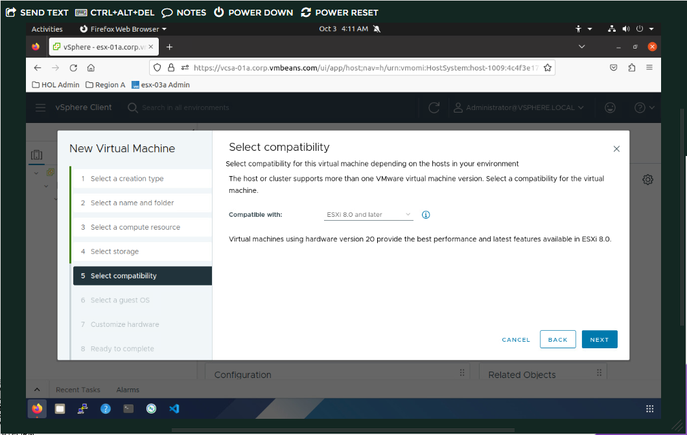
Step6: Select Guest os
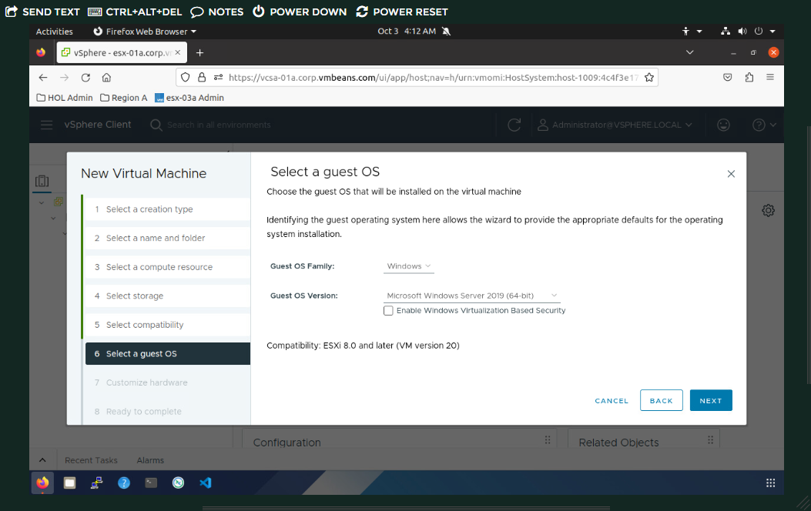

Step7:- Customize hardware according
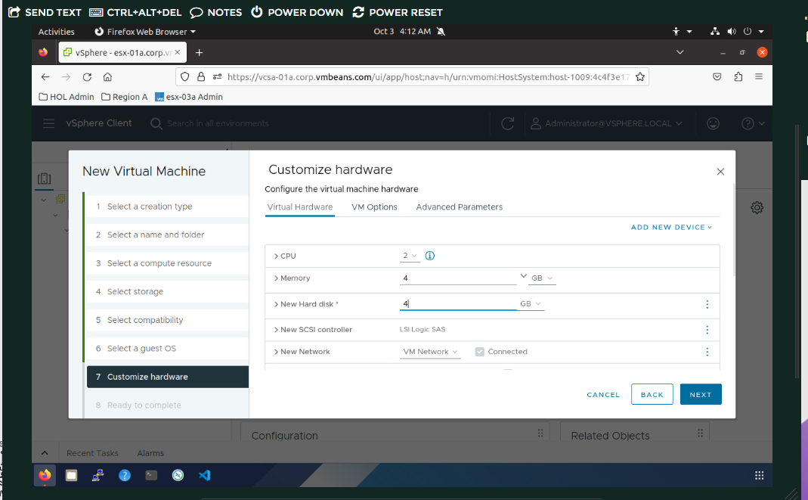
Step8:- ready to complete and click on finish button
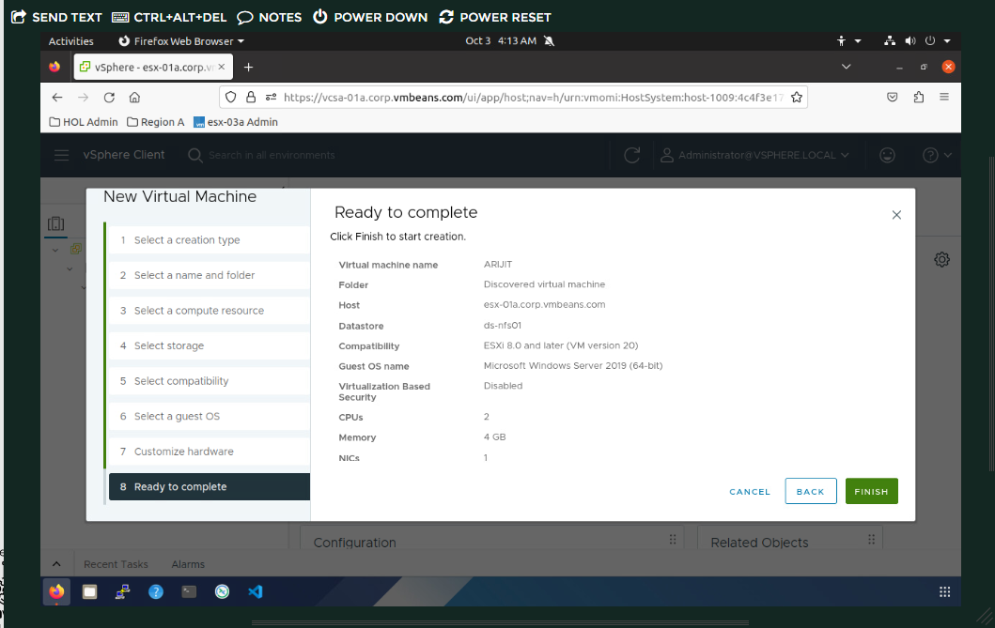

Step9:- your vm is ready to work
Question2
Ping Commands:
1.Instagram Ping
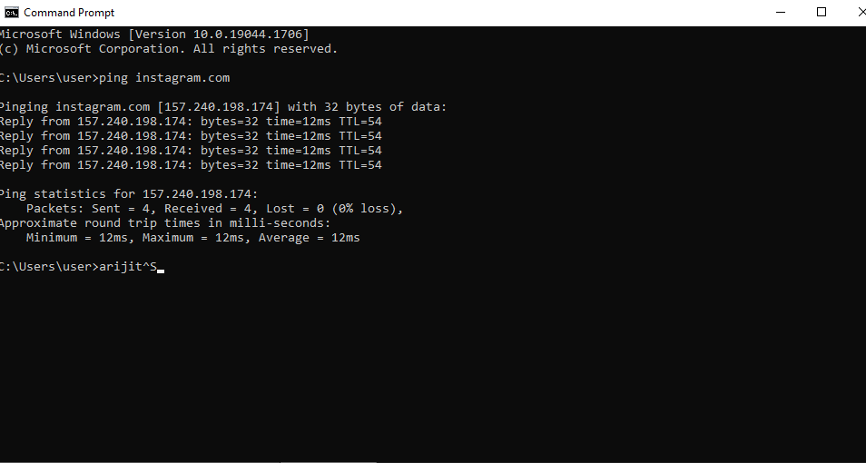

2.Google.com Ping
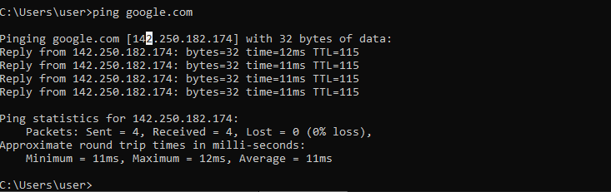
3.Youtube.com Ping
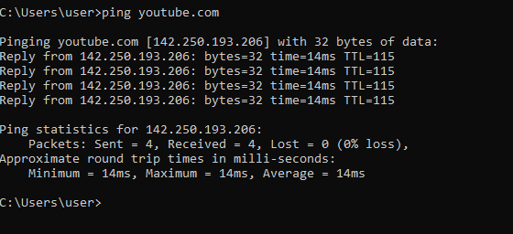

Question3:
Snapshot In HOL: →Open virtual machine in HOL Create a virtual machine and give right click on Virtual machine Right click on Virtual machine → Snapshot → Take Snapshop



